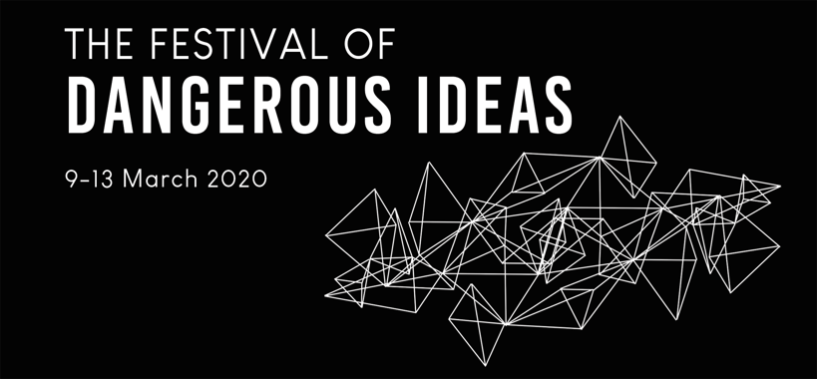
Topic:

Hook (a question, an object, or a picture that captures the visitors’ attention):

Key Idea #1 (please provide a detailed explanation)

Key Idea #2 (please provide a detailed explanation)

Conclusion: This idea is dangerous because...

