A Slur Directed at Me

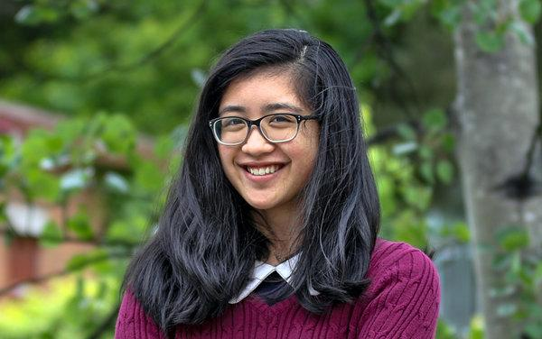
Marianne Nacanaynay, 15, Youth Radio Mountlake Terrace, Wash.
Filipina
The first time someone directed a racial slur toward me I was at a pizza place in Everett, a town in western Washington State. One of my friends who works with me on our high school newspaper wanted to get lunch early, and the place was already crowded with a line stretching around the block. I was waiting outside of the restaurant and chatting on the phone when out of the corner of my eye, I saw two dudes walking by. They were young looking — teenagers or 20-somethings — with light skin and blond/brown hair. As they passed me, I heard them laugh and say, “(expletive) chink.”
It took me a few moments to process what I had just heard. I was taken aback, but not exactly surprised. After all, there I was, a Filipina reporter covering a Trump rally.
Washington State tends to be super liberal. We had the first elected married gay mayor of a major American city. We’ve legalized recreational marijuana. Until recently, Republicans I knew here were mostly “in the closet” in the sense they didn’t talk much about their opinions in public. But I’ve learned that doesn’t mean racism doesn’t exist in Washington — it’s just typically a less overt brand of racism.
Growing up, I lived in Auburn, a suburb south of Seattle, and there weren’t a lot of other kids who looked like me. Back then, it didn’t bother me, because I didn’t think too much about race. My family raised me with phrases like “People are people,” and “It’s who you are inside that counts.”
I remember the time I had a white classmate come over to my house for dinner. We served adobo, which is chicken or pork that’s been marinated in soy sauce or vinegar then fried, and ube, a dessert made of purple yam. The girl politely tried everything but mostly pushed the food around the plate. When I asked her about it later, she said the flavors weren’t familiar to her.
Then in sixth grade we moved to Mountlake Terrace, a suburb about 20 minutes north of Seattle with a noticeable Asian population. Being around more Asian friends, I found myself reflecting differently on my interactions with white peers.
I brought a plate of the same adobo to a party, and people loved it. Having people like my culture made me feel more comfortable with it, too.
So, after years of slowly opening myself up to having pride about my race and culture, hearing two boys call me a chink in the middle of a pizza place was a snap back to reality. On the one hand, it was so over-the-top, it was almost comical. I mean, it’s not even the right racial slur, since I’m not Chinese.
Sometimes I think back on that incident, like when I hear about other people being called a racial slur, or when I hear about people harassing others at Trump rallies. And I remember how I felt vulnerable. It’s a reminder that there are some places where I am still considered the “other.”

- What happened to Marianne and what was her response?
•What is your personal reaction to this story?
•Why do you think Marianne wasn’t initially surprised when she heard the slur directed at her?
•What does Marianne mean when she says Washington has a “less overt” brand of racism?
•In what ways did Marianne think differently about her interactions with white peers after she moved to a town with more Asian-American people?

