Followed by a Police Officer
e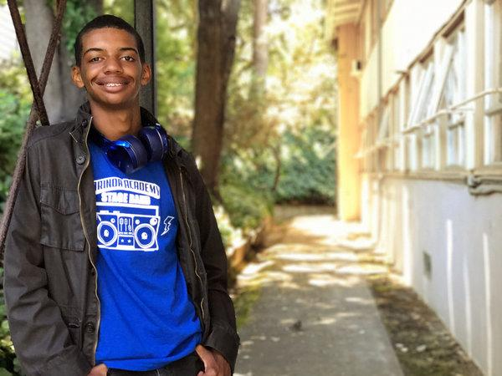
Riley Lockett, 16, Youth Radio Oakland, Calif.
Black
About two months ago, I was walking to the BART station from school, sipping on soda and listening to a podcast when I noticed a blue uniform following me like a shadow. It was a white police officer. He scanned me as if he were the Terminator, trying to see if I posed a threat. I had never been stopped by a cop before. But I wasn’t scared or even nervous. I was prepared.
My mother was always gearing me up for something: a good education, future job security and, most of all, institutionalized racism. Every time we passed a police car, she would drill my sister and me on what to do if and when a police officer stops us. We would begrudgingly repeat what our superior said: “Maintain eye contact, stand straight, speak when spoken to, no sudden movements.”
As children, we never understood why she grilled us like that. Then, when I was 12, Trayvon Martin was killed. Even though it wasn’t a cop who killed him, I started to comprehend what she was preparing us for. Although we live in a quiet suburb of Oakland, we are in a city where a police officer is usually seen as more of a threat than a friend. As a young black man, I know an officer of the law can shoot me no matter where I am — and maybe especially in the middle of Orinda, the mostly white city where I was being stopped for the first time.
So, as the cop was questioning me, I decided to practice what my mom preached.
“Is there a problem, officer?” I asked in my most articulate, mature, but nonviolent voice.
“No. What’s your name?”
“Riley Lockett.”
“How old are you?”
“Sixteen.”
“Where do go to school?”
“Orinda Academy, just up the hill. But I live in Oakland.”
“Do you have ID?”
“Yes, here you go.”
I felt like I was performing a one-man show I’ve been rehearsing my whole life. He eyed my ID, then looked through me while handing it back. He turned on his radio and mumbled some breaker-breaker nonsense into it, and in a few seconds he got a few squawks back.

“You’re free to go,” he said to me in a tone that made it sound like his mind was on something else.
I felt bold enough to ask, “What was the problem, officer?”
“Oh, some guy robbed a convenience store a couple streets over,” he told me. “He fled in this direction, and you matched the description.”
I’ve never had to face the color of my skin in anything but a mirror. So as far as police interactions go, I’d say my first one went pretty well. I know there will be plenty more as I get older.
Having to spend my childhood rehearsing for the day a police officer would pull me over may sound scary. And I’m aware it’s not something parents of all races feel the need to teach their kids. But the day it actually happened, I was grateful, at least, that my mom made sure I was ready.

What happened to Riley and what was his response?
•What is your personal reaction to this story?
•How was Riley prepared for his encounter with the police officer?
•Why does Riley say that in his community, a police officer is usually seen more of a threat than a friend?
•What impact do you think his needing to “prepare” has on him?

